Guide / Tutorial / Suggestions for configuring Playnite

Table of Contents

Special thanks 2

Structure of this document 2

Quick tips first 3

Details View (Theme HeliumWithTabs) 4

Playing short trailer videos 5

Add Age Rating icon 9

Display Number of (Steam) players In-Game 10

View Similar Games 11

How Long To Beat 12

Top Panel icons to filter games quickly 13

Identifying Playstation Essentials vs Extra vs $$$ 14

Custom spreadsheet 15

Sort Games by Paid Price (using Version field) 15

Sort Games by Popularity (using Play Count field) based on the Number of Reviews 16

Filtering Nintendo Switch Roms 17

Help me decide on what platform I should be playing a game 18

View Steam Wishlist + notifications 19

Count the number of games selected 20

Identify coop games 22

Identifying games with cross-platform multiplayer 23

Display icons to show the Features of a game 24

End result for Features 25

Best extensions (so far) 26

Other great extensions: 27

More Global settings 27

ThemeModifier 30

Cleanup links 31

Backups 32

General suggestions for improving Playnite 33

Suggestions for new extensions/themes 33

# Special thanks

Most extensions I use are from darklinkpower: <https://github.com/darklinkpower/PlayniteExtensionsCollection>

So special thanks to him 😉 <http://ko-fi.com/darklinkpower/> and to Josef Nemec <https://www.patreon.com/playnite>

All suggestions below are related to his Theme [**Helium**](https://playnite.link/addons.html#8b15c46a-90c2-4fe5-9ebb-1ab25ba7fcb1), I’ve made my own version of it here: [https://github.com/tetj/HeliumWithTabs](https://github.com/tetj/Helium)

Maybe the following can give them some ideas for new features.

Also, there are so many extensions, it could be great to have some pre-packaged and pre-configured somehow.

# Structure of this document

The instructions below follow this pattern:

1. Screenshot of the feature
2. TODO = My wishlist = things to improve
3. How I did it

# Quick tips first

** Before going any further, I suggest you make a backup of your data.

To do that, you could use the menus:

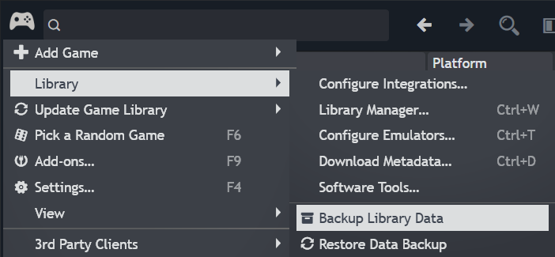

But to navigate more quickly in general, press CTRL-F and type Backups.

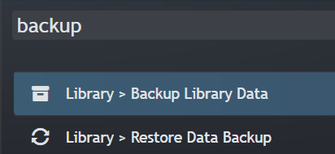

# Details View (Theme HeliumWithTabs)

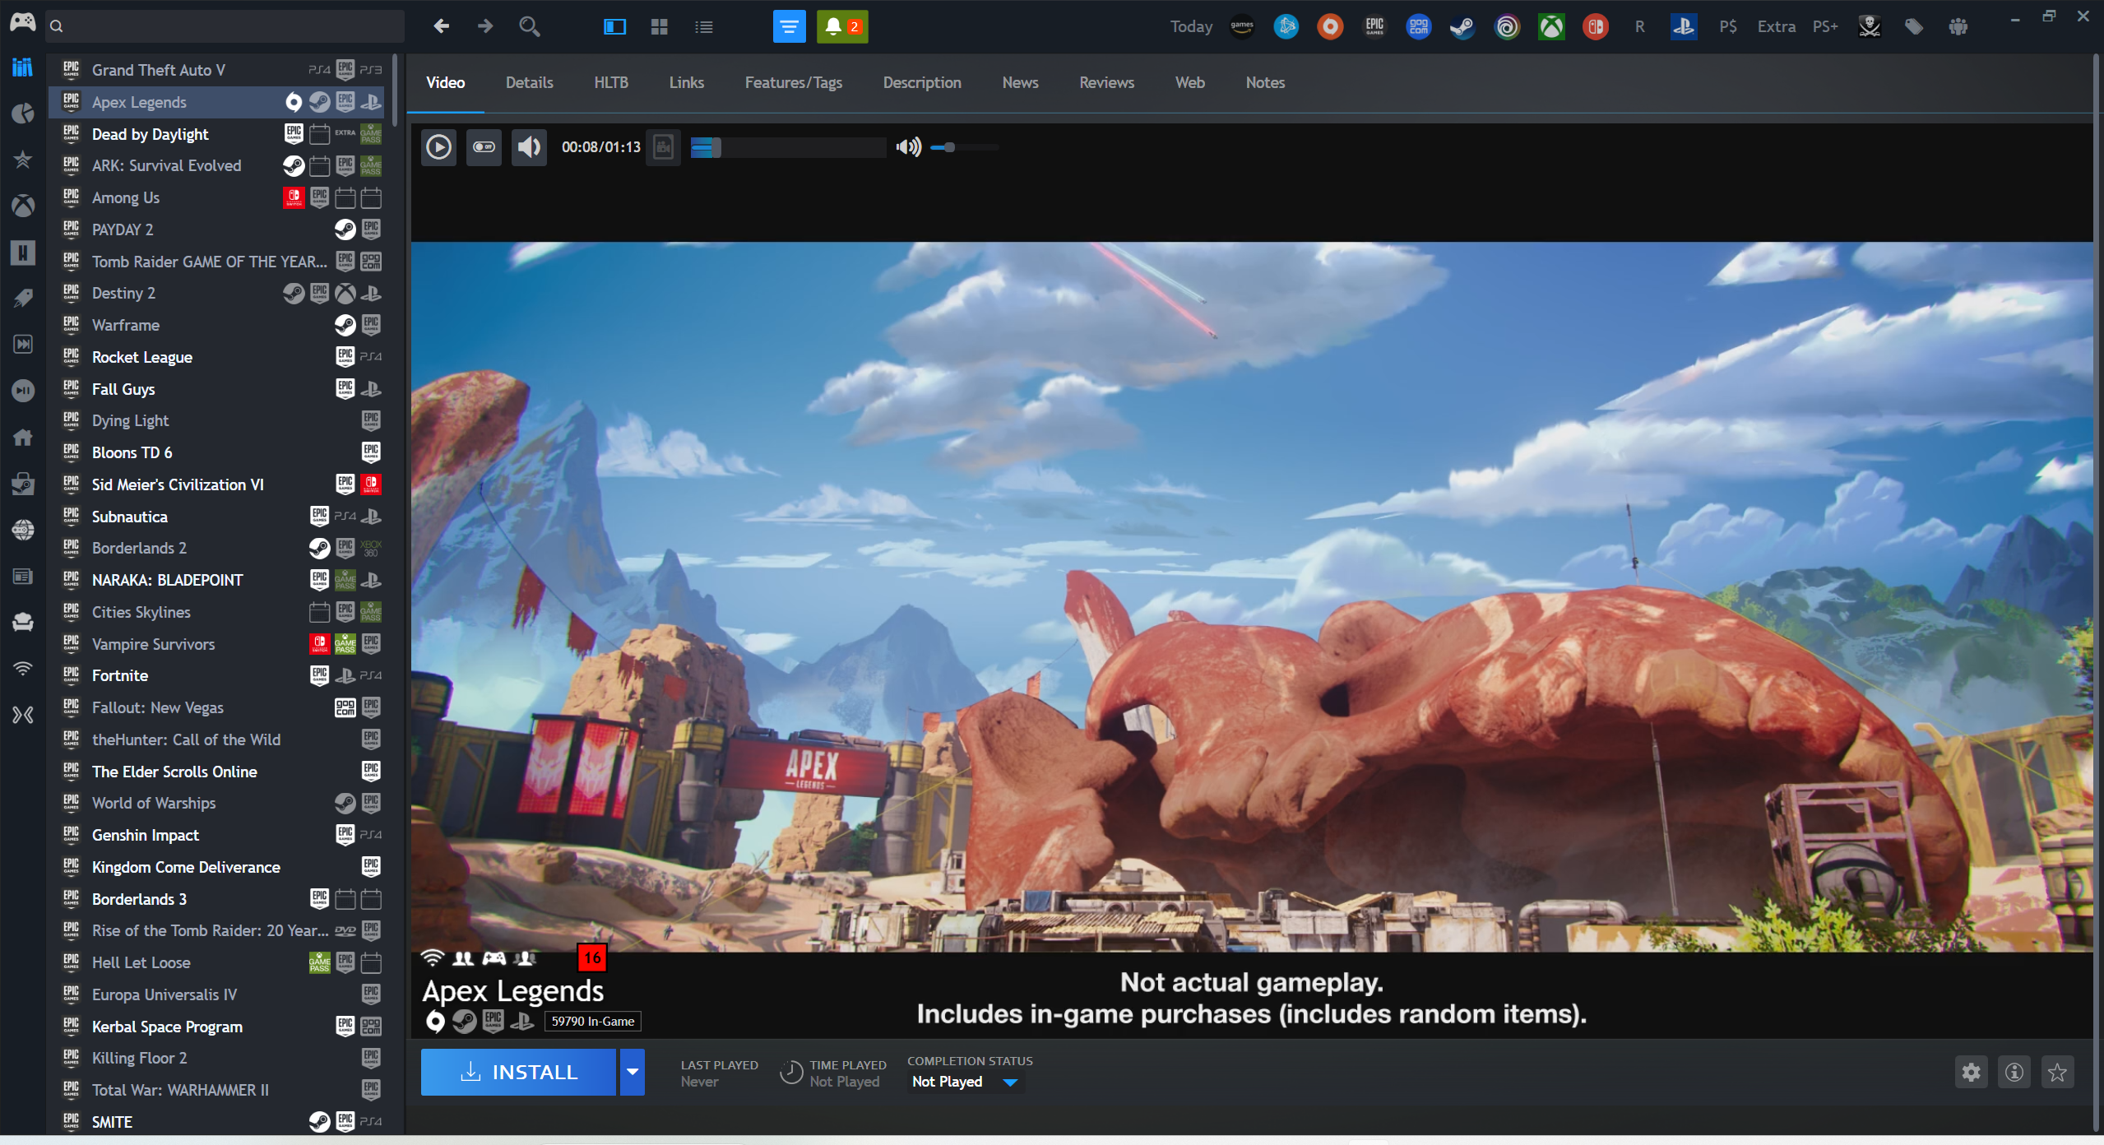

# Playing short trailer videos

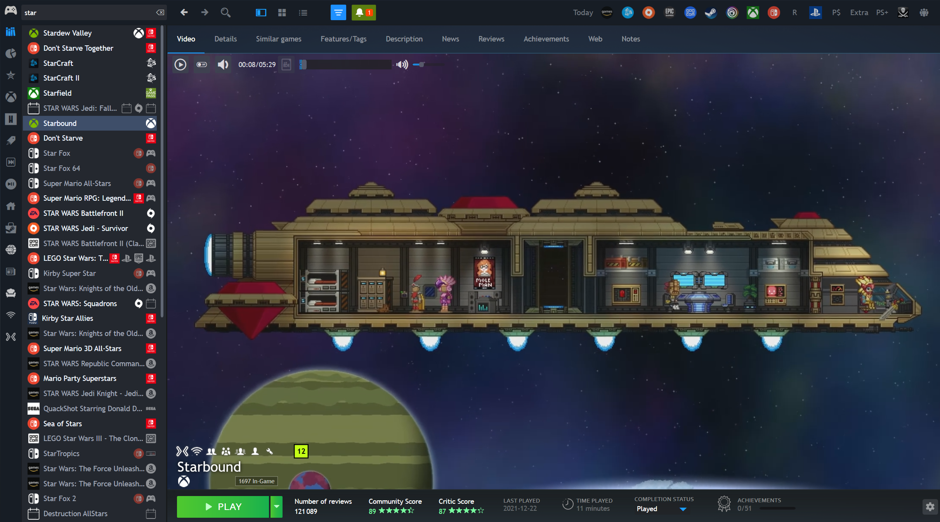

**How I did it**:

You need [**Extra Metadata Loader**](https://playnite.link/addons.html#ExtraMetadataLoader_705fdbca-e1fc-4004-b839-1d040b8b4429)pluginwith the following **configuration** (my preferences):

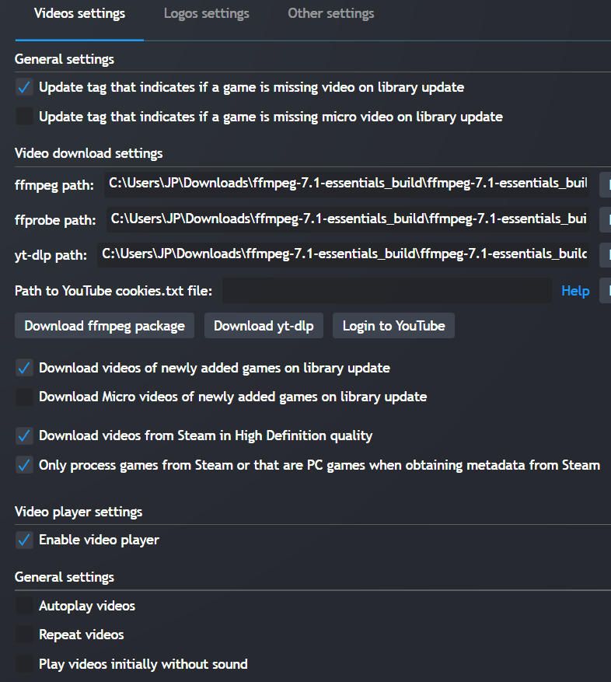 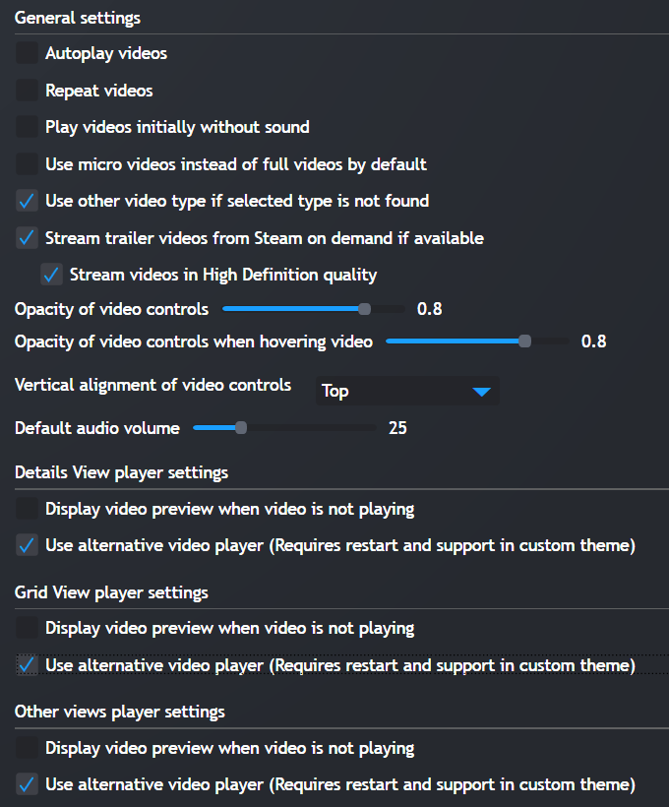

For more details, please see: <https://github.com/darklinkpower/PlayniteExtensionsCollection/wiki/Extra-Metadata-Loader>

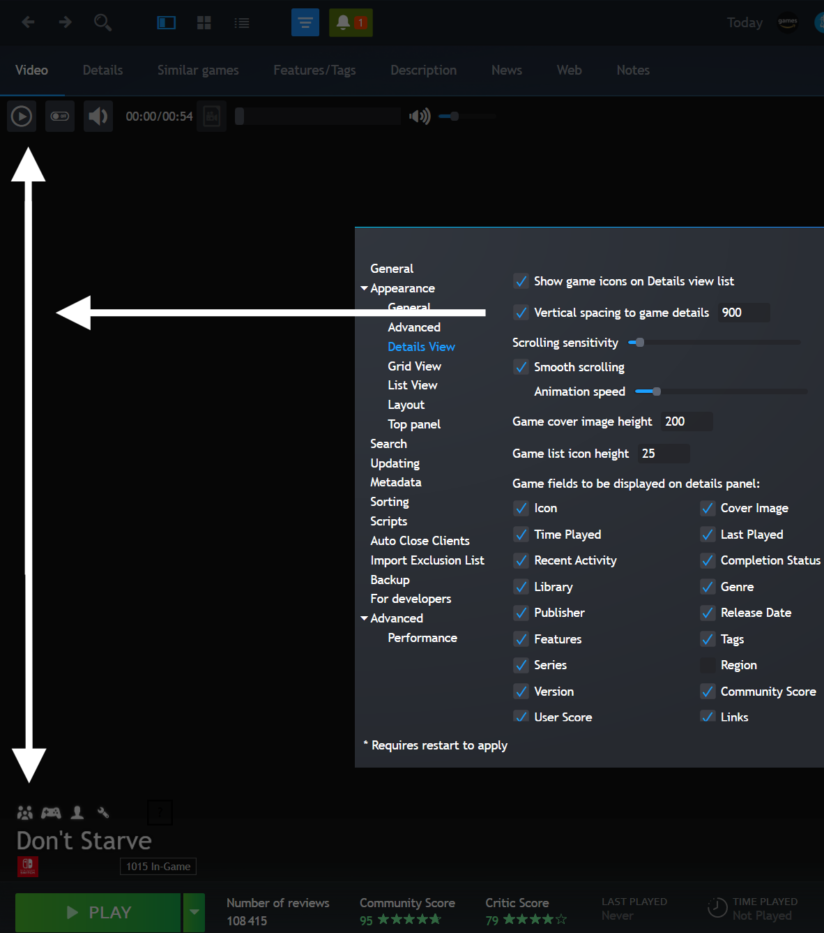You will also need these settings (Edit: Game cover image height = 300):

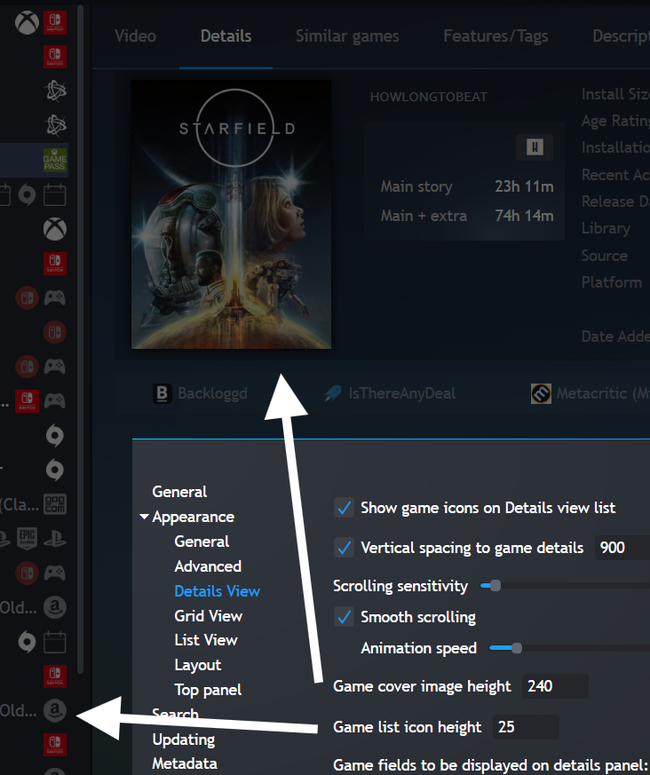

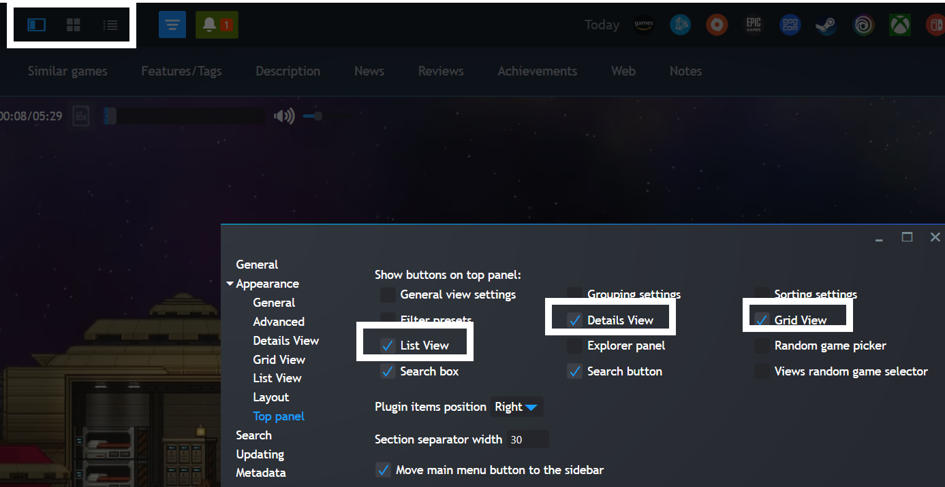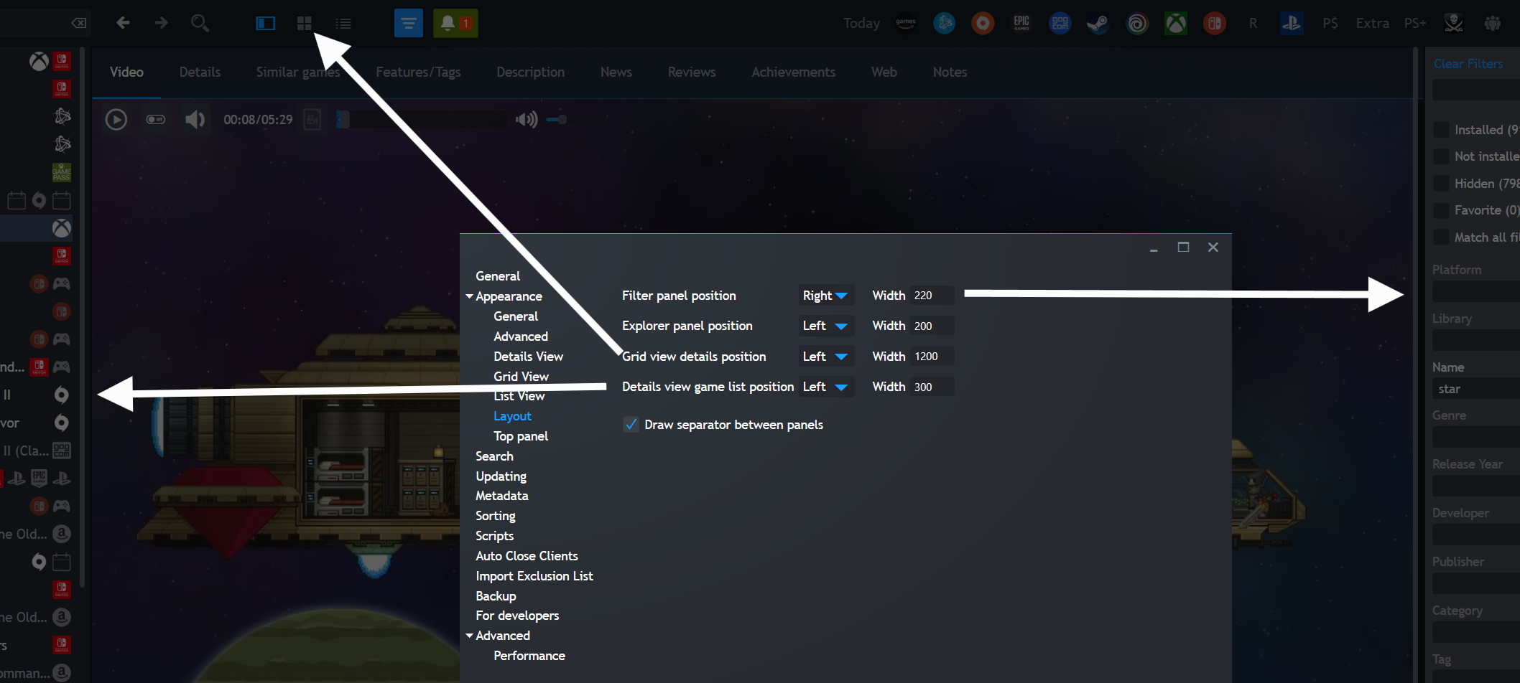

# Add Age Rating icon

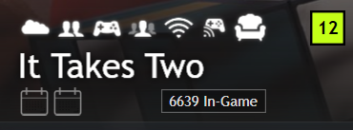

**How to:**

* for now, it requires [my version](https://github.com/tetj/Helium) of the Helium theme, until darklinkpower adds support for it

**To change the colors** (I wanted 3 colors: white for PEGI 7, yellow for PEGI 12 and red for PEGI 16/18):

* requires [Library Management](https://playnite.link/addons.html#playnite-librarymanagement-plugin) extension (requires version [3.1.1](https://github.com/Lacro59/playnite-librarymanagement-plugin/releases/download/v3.1.1/playnite-librarymanagement-plugin_3_1_1.pext) to avoid a bug)
* after the changes are done to the colors, you can switch back to version 3.2

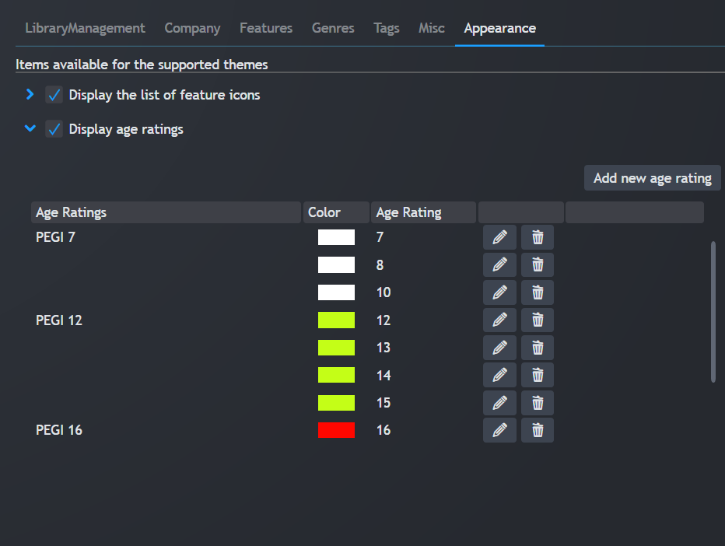

# Display Number of (Steam) players In-Game

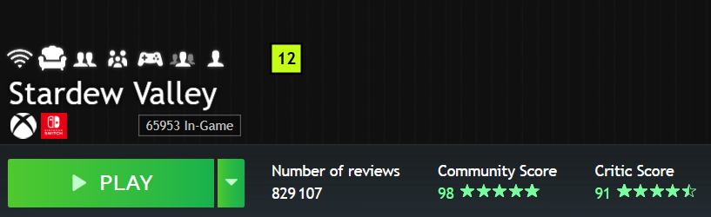

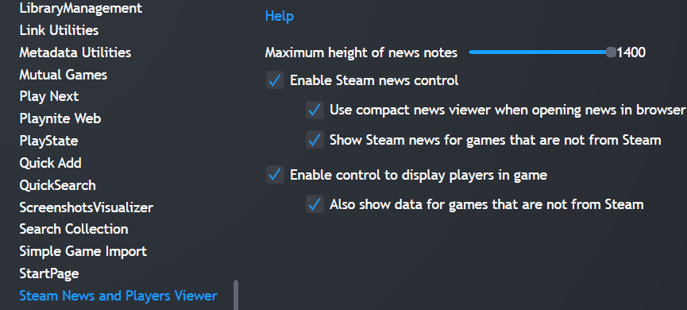

**How I did it:**

* You need the [News Viewer extension](https://playnite.link/addons.html#NewsViewer_15e03ffe-90f6-4e8e-bd4d-94514777481d)

**Configuration:**

* I wanted to see it for ALL games, not just Steam games
* Unless darklinkpower makes it configurable in his theme, you will need my version of the Helium theme if you want this number to show below the game name, else it shows in the **top right corner**.

**TODO**:

* It would be nice to be able to **sort** the games by number of players in game (but I would need an additional field/column in the database)

# View Similar Games

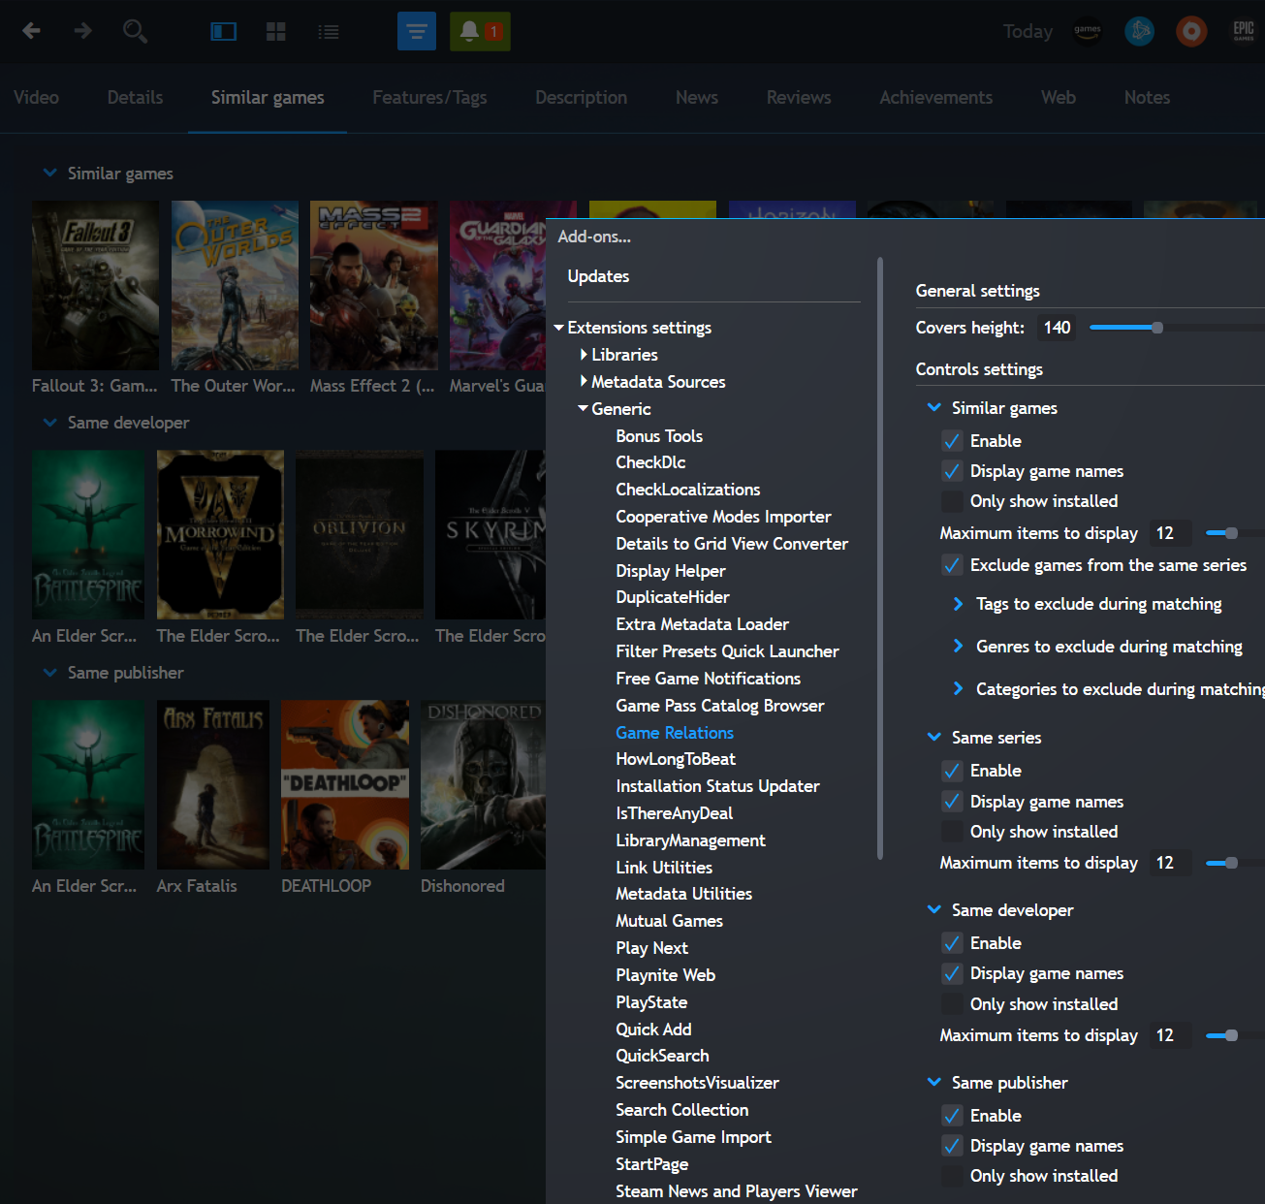

**TODO**:

* interesting way to get Game Recommendations somehow, similar to [**Play Next**](https://playnite.link/addons.html#SparrowBrain_PlayNext)extension, I think there is room for improvement, let’s use AI to make it as powerful as Netflix and social media feed/recommendations algorithm? It could be based on Steam wishlist, game popularity, score, age rating, etc. Even price and IsThereAnyDeal.

**How to:**

* I changed the [Game Relations](https://playnite.link/addons.html#GameRelations_a4c15d63-9ab4-4d96-9a0c-8f9b35d43a1f) source code a bit to remove duplicates for example, let’s see if darklinkpower integrates these changes
* Also changed it so games that are not installed have no transparency, it looks much better imho
* I disabled same series, same developer and same publisher the games were often the same as Similar Games and I was not really interested in knowing other games from the same developer anyway.

# How Long To Beat

For **HowLongToBeat**, I’ve done some small changes to the source code to make it simpler / more compact, see: <https://github.com/tetj>

**TODO**: instead of having to change the extension settings, allow the user to make these changes more easily like they did in [this theme](https://github.com/eminaguil/eMixedNite).

In that theme, the user can toggle the visibility of certain elements simply by clicking on these icons:

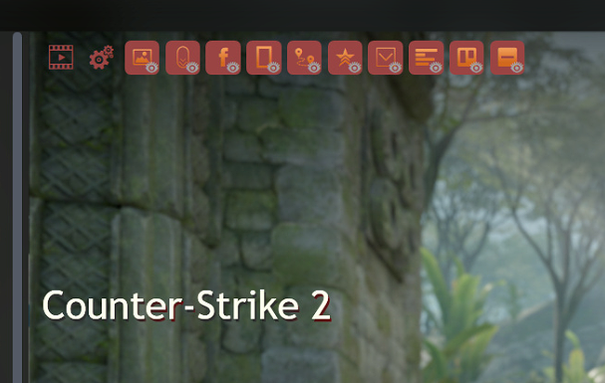

# What games to play first to make room on my PS5?

1. Using Playnite Filters, filter games with Platform = PS5
2. Using HowLongToBeat plug-in, select “Playnite data” tab, then select “currently filtered”, then sort games by Install Size or Remaing Time
3. Optional: add games with a large file size and a short remaining time to a specific Playnite category, making it easy to access them when needed.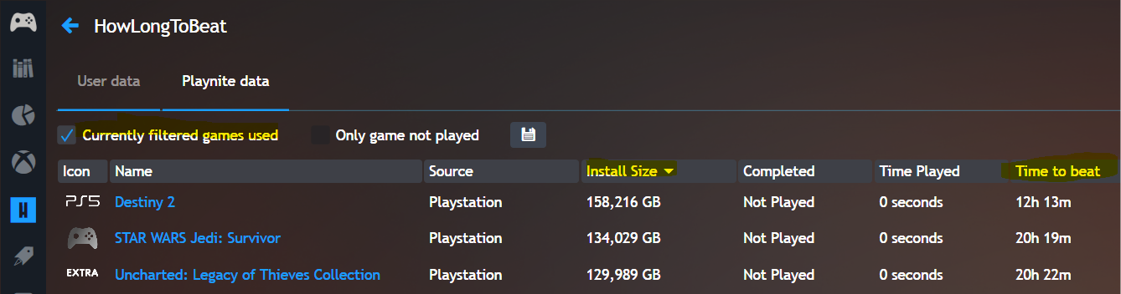

# Top Panel icons to filter games quickly

**How it looks:**



**In order to do that:**

I’ve used Playnite **Filters** + “Filter Presets Quick Launcher”

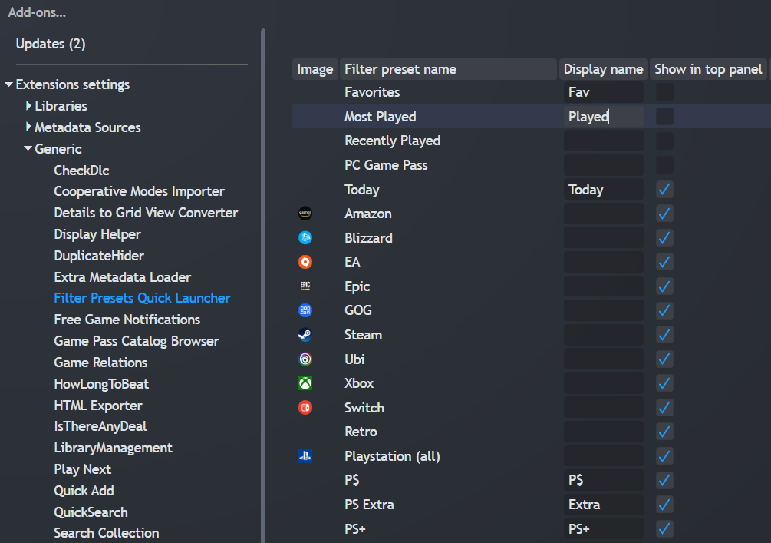

You can find the icons I’ve used here: <https://github.com/tetj/BonusTools/tree/master/icons>

# Identifying Playstation Essentials vs Extra vs $$$

For the filters, most are pretty easy to create, except:

* **PS$** = Games I’ve purchased
* **PS Extra** = PS extra (catalogue)
* **PS+** = PS essential (monthly games)

For these 3 filters, I created the following extension: <https://github.com/tetj/BonusTools/tree/master>

To use that extension, you will need to:

* Download [data request from PSN](https://www.playstation.com/en-ca/support/account/data-request/)
* Download [Master List](https://docs.google.com/spreadsheets/d/19RorxFhWc2lHocg4c9zrVssSwZq1u2nPcpTsAvzdJQw/)
* CTRL-F -> Add-ons -> Generic -> BonusTools -> Set the path for the 2 files previously downloaded (see image below)
* Select all your games -> Right-click -> BonusTools -> Import **PS Price Paid**
* Select all your games -> Right-click -> BonusTools -> Import **PS Plus Status**

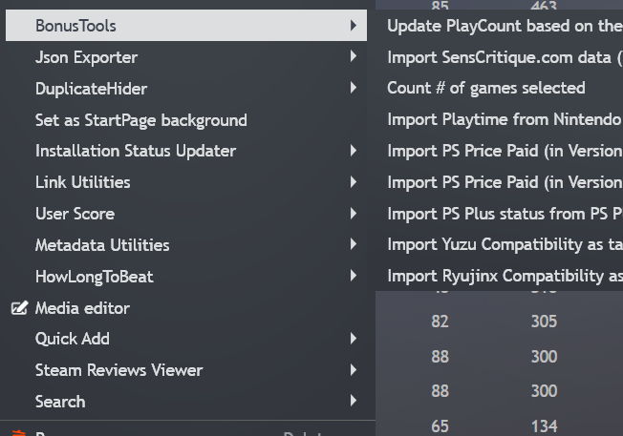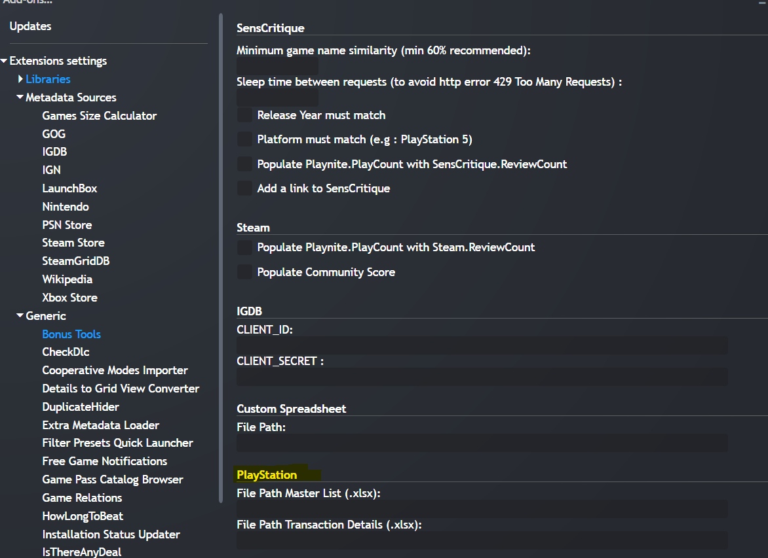

TODO: An alternative could be to use this <https://github.com/mrt1m/playstation-store-api/blob/main/examples/ps_plus_essential.php>

# Custom spreadsheet

You can also importe PS Price from a **custom spreadsheet**:

The spreadsheet must have 3 columns in a tab named “Sheet1”:

1. game name
2. platform … must match the platform names in Playnite
3. price ... must be a whole number, no decimals, no dollar sign … so **$30.99** should become **30**

First row is ignored (usually used as the column header).

The program will format the price to 4 digits, so the string can be sorted like a number, in the case above, the Version field will be **3000**

# Sort Games by Paid Price (using Version field)

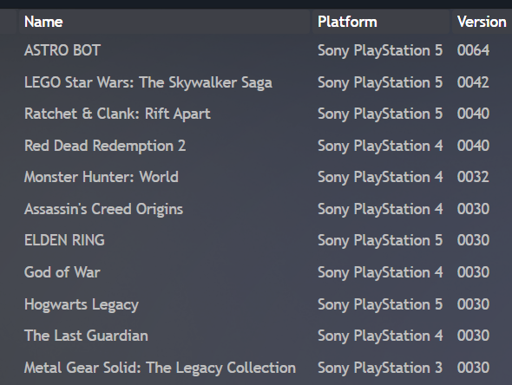

# Sort Games by Popularity (using Play Count field) based on the Number of Reviews

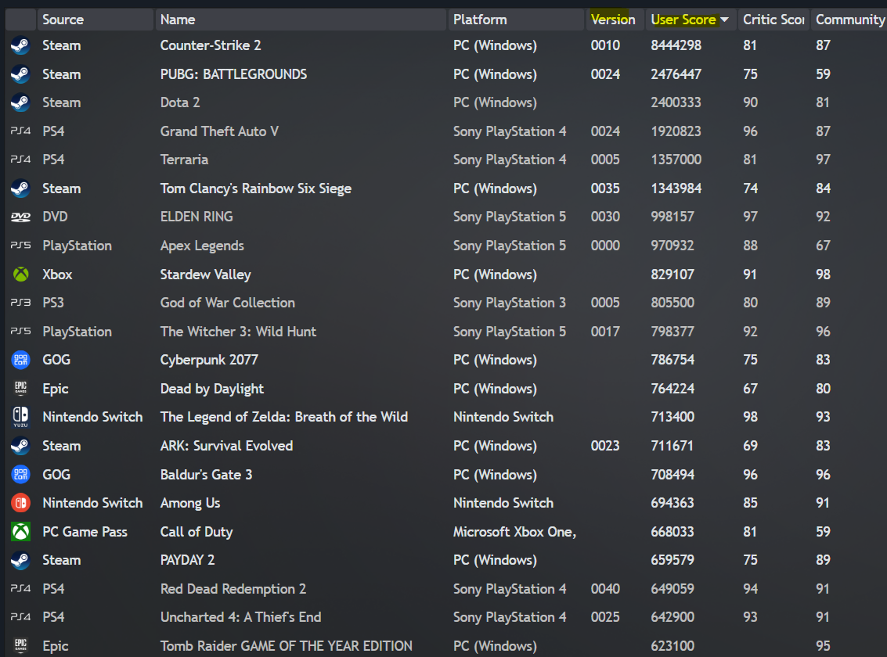

In the image above, this is from an older version. Previously the **User Score** field was used instead of the **Play Count** field for that feature.

In order to do that, you will need to use my plugin that you can find here: <https://github.com/tetj/BonusTools/tree/master>

It uses the number of reviews:

1. From Steam (but since not all games are on Steam it uses SensCritique and IGDB as fallbacks)
2. From SensCritique, multiplied by 50 (to be closer to the number of reviews on Steam)
3. From IGDB, multiplied by 300 (since IGDB is much less popular) as last resort.

Also, you will need to disable the Play Count from being overwritten by the PS integration:

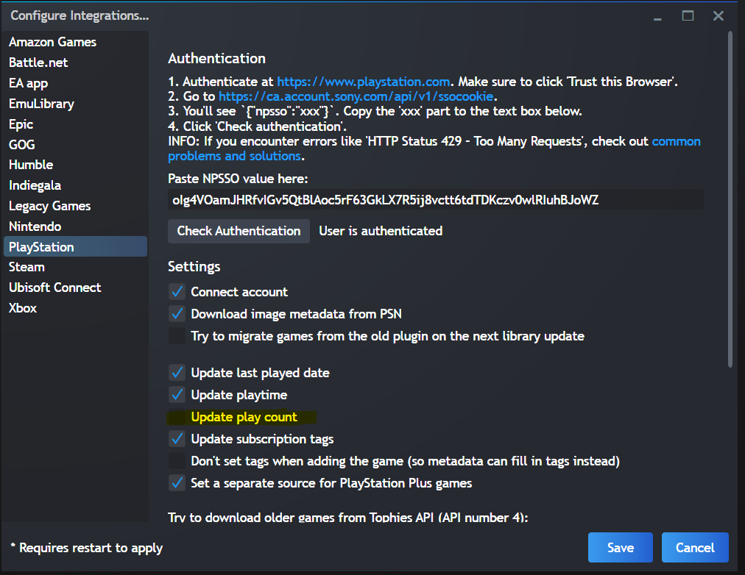

# Filtering Nintendo Switch Roms

Also, for the **Switch**, I wanted to import my NSP files (roms) because I wanted to use an emulator.

I’ve explained how to achieve do that here: <https://github.com/tetj/BonusTools/blob/master/documentation/ImportingSwitchNSP.md>

Please note this plugin is not very user friendly but it does the job for what I needed.

Regarding the filter **Today**, it’s based on **Date Added** = Today.

# Help me decide on what platform I should be playing a game

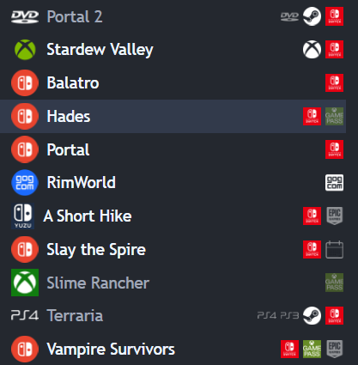 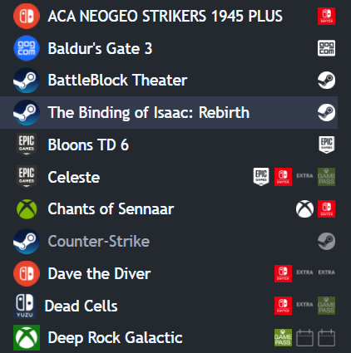

**Why**? Let’s say I have a game on PS **Extra** (subscription) and **Switch** (paid) such as Dave the Diver. It does not make much sense to play it on PS Extra since the game can leave at any moment on that platform. Unless I really cared about PS trophies.

**TODO**:

* Icons could be larger on the right
* Some icons are not set automatically when importing new games, I need to automate that
* Would be nice to have an icon for crossplay (see co-optimus) and one for online multiplayer and one for local multiplayer, see these [icons](https://github.com/tetj/BonusTools/tree/master/icons/features)

**How to**:

* Using DuplicateHider, add icons here: C:\Users\**You**\AppData\Roaming\Playnite\ExtensionsData\382f8003-8ed0-4e47-ae93-05b43c9c6c32\source_icons
* Icons can be found here: <https://github.com/tetj/BonusTools/tree/master/icons/source_icons>
* For the DVD icons, I had to do it manually, I don’t have a lot so it was quick, I created a **Source** named DVD
* For the **Calendar** icons, this is to show which games are on **PS Plus** Essential (monthly games)
* For the **Extra** icons, same principle but for **PS Extra** games

# View Steam Wishlist + notifications

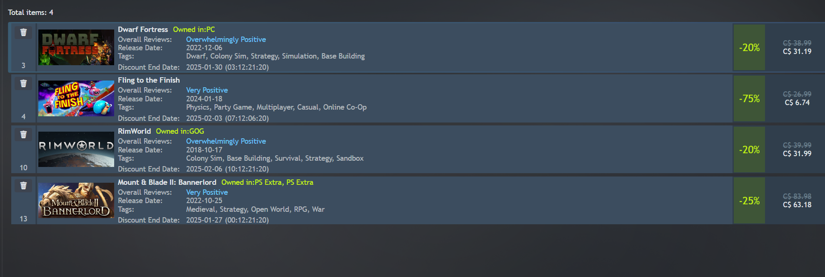

**TODO:**

* Would be nice to see the ATL (All-Time Low aka Lowest Recorded Price)

**How to:**

* Really easy, just download the extension here: <https://playnite.link/addons.html#SteamWishlistDiscountNotifier_d5825a82-42bf-426b-ac47-5bea5df7aede>

# Count the number of games selected

Just a quick tip, using the [**Quick Add**](https://playnite.link/addons.html#QuickAdd_44def840-a5dc-4fdf-8fd7-37ffe57187d6) extension, you can count the number of games selected, simply Add games to a Category.

You can use CTRL-W to add a new category and name it Count.

Don’t forget to **Quick Remove** Count from selected games after each count.

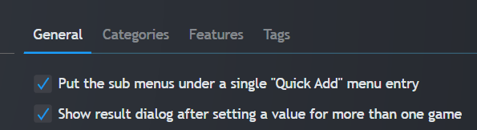

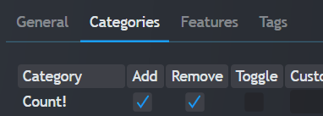

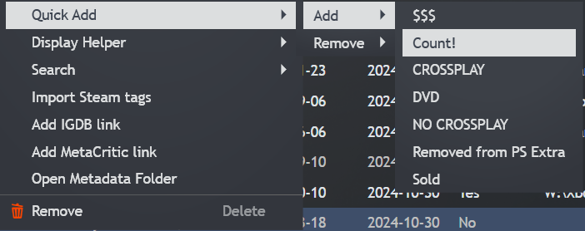

**TODO**:

* change the [Quick Add](https://playnite.link/addons.html#QuickAdd_44def840-a5dc-4fdf-8fd7-37ffe57187d6) extension to have built-in Count (without having to remove each time) or create a dedicated extension
* even better would be built it support within Playnite, simply shows the number of selected games/rows somewhere like Excel does

**Alternatively**, you can use the [Metadata Utilities](https://playnite.link/addons.html#MetadataUtilities_485ab5f0-bfb1-4c17-93cc-20d8338673be) extension from the same developer.

Once installed, press CTRL-F and type “Metadata Editor” to get there.

Using this extension, you see the **Game Count** for various filters. It’s great to find interesting quick filters to create.

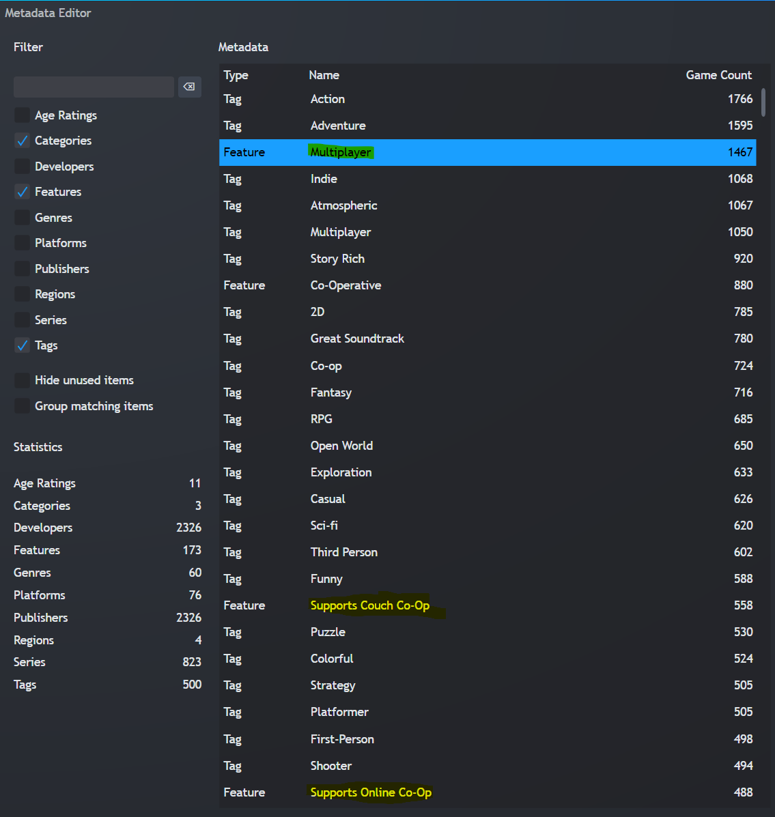

# Identify coop games

**Result** = See highlighted yellow icons below.

**How to** = Using the [Cooperative Modes Importer](https://playnite.link/addons.html#CooperativeModesImporter_9767ac15-6e26-4e4c-9d69-f6838625dde3) extension, I was able to filter games having these Features :

* Supports Online Co-Op
* Supports Couch Co-Op

To populate your Features with Co-Optimus data, press CTRL-F, then type “update coop”.

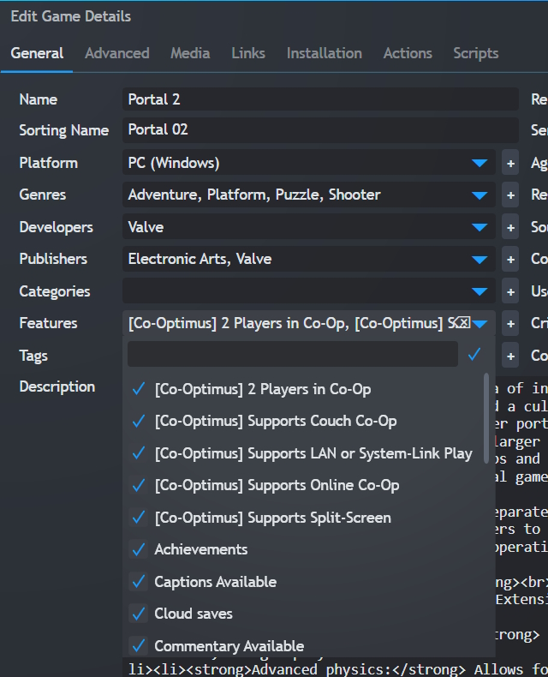 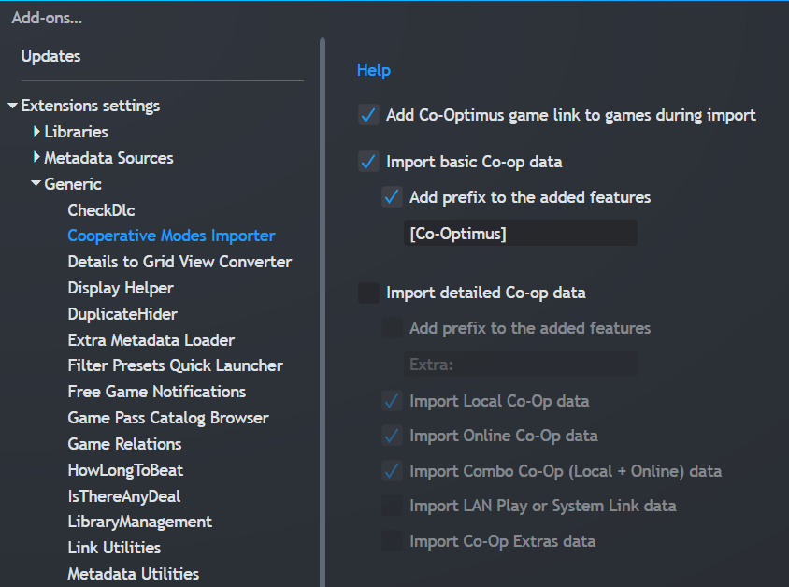

I could have used Steam Features instead but most of my games are not on Steam so Co-Optimus should be more accurate.

I suggest using the **same settings as me** to keep your Featureseasy to understand**.** Then I created a Quick filter for each of them.

Now regarding online games, there is an extension <https://playnite.link/addons.html#MutualGames> that can be quite useful.

# Identifying games with cross-platform multiplayer

In order to do that, you will need to have Steam Store as your metadata source for Features.

Alternatively, you can use the [**Steam Tags Importer**](https://www.reddit.com/r/playnite/comments/1dm1aw7/steam_tags_importer_has_a_purpose_again/) extension.

Once installed, to get to the screen below, you need to use Main menu > Extension > Steam Tags Importer property -> search for Cross -> Select

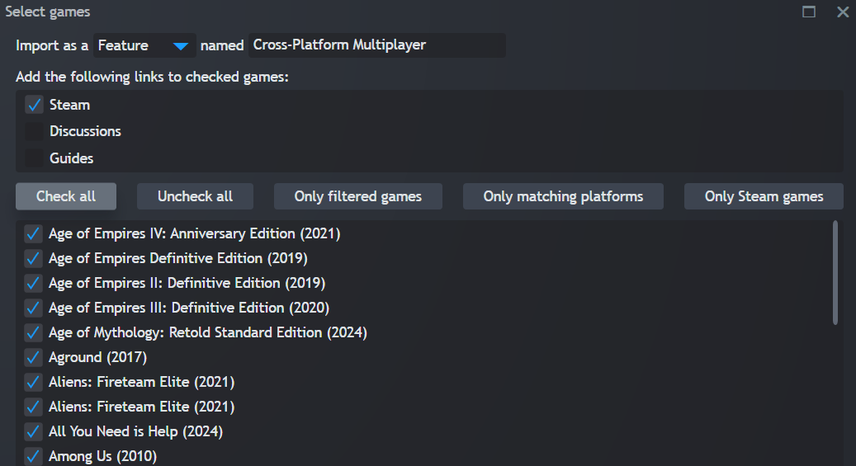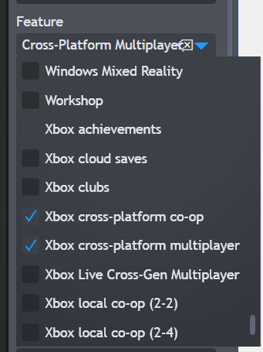 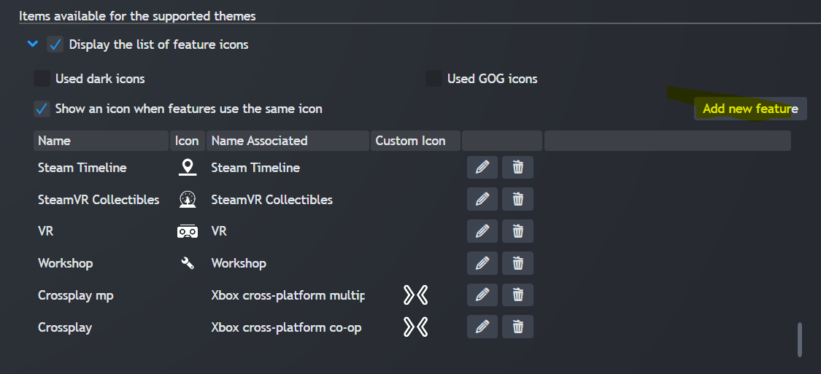

You will need “my” custom icons found here: <https://github.com/tetj/BonusTools/tree/master/icons/features>

If I’m on my PC, then **online** makes sense. If I’m going to sit in front of the TV, then **couch** co-op 😉

There are some games I own on multiple platforms so that’s where **cross-platform** becomes useful.

# Display icons to show the Features of a game

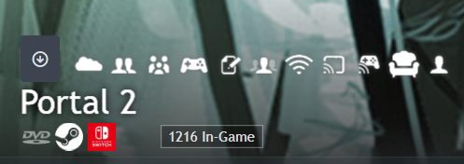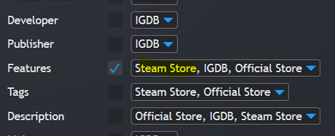

**How to:**

* As explained above, you need this extension: [Universal Steam Metadata](https://playnite.link/addons.html#Universal_Steam_Metadata) + [Library Management](https://playnite.link/addons.html#playnite-librarymanagement-plugin)
* Then you will need to set **Steam Store** as your first/default source when downloading Metadata (CTRL-D)
* If you already have **features** from other sources, you might need to refresh **all** your games by selecting unchecking “only download missing metadata”, which makes take a **long time**.

You can configure these to your preference using the Library Management. For example, I don’t like **VR** so I removed all these. Then I did not like that it uses the same icons for most multiplayer features. I wanted to separate **online** versus **local** coop so I changed the icons.

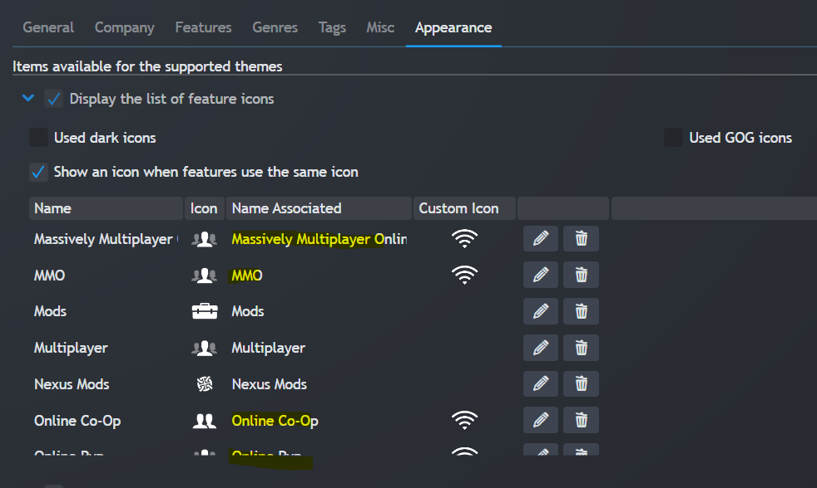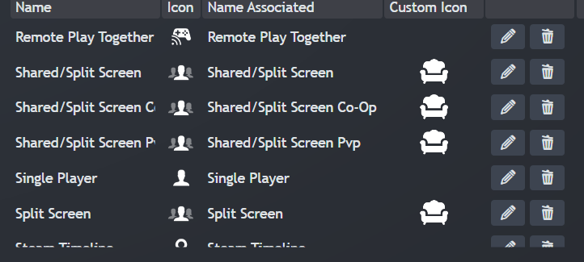**TODO**: it would be nice to be able to re-order them. I would like to see the Couch and Wifi first. Maybe do something like [this in top right corner.](https://raw.githubusercontent.com/eminaguil/eMixedNite/main/screenshots/screenshot_01.png) I would also group Singleplayer, Coop, Family Sharing. For now, it seems to be in alphabetical order. It would also be nice to be able to hide some features/icons without deleting them “forever”.

# End result for Features

I ended up keeping only the essential icons for me:

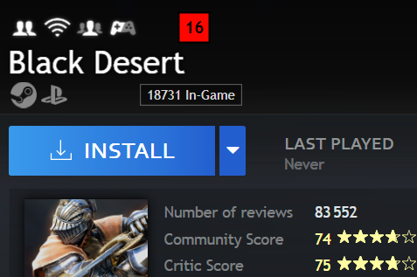

This way, I can **quickly see** that this game is:

* Coop
* Online
* MP
* Partial controller support
* A bit too mature for my kids
* I could play on Steam while my kids play on PlayStation but it does not seem crossplay so we will need to play both on Steam
* No couch coop unfortunately
* Quite popular with 18 731 players in-game
* But reviews are average so I’ll probably play something else first
* And the game is not from PS Extra / PC Game Pass so there is no rush to try this one.

# Best extensions (so far)

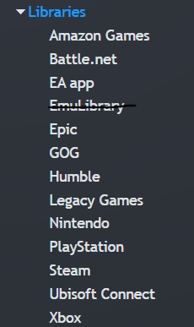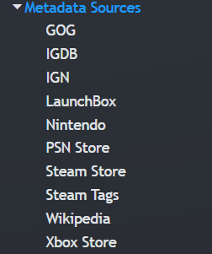 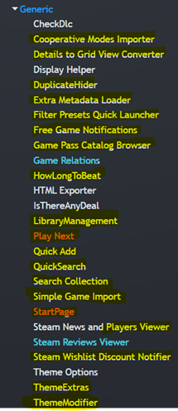

Yellow = must useful

White = I have not used much yet

Red-Orange = Cool concepts but I’m not sure I’ll use them much, I would need to customize/improve them

Light blue = I’ve changed them a bit using C# (TODO: upload changes on github)

# Other great extensions:

* [Simple Game Importer](https://playnite.link/addons.html#SimpleGameImporter_6048b590-bdfb-4a88-8953-2985b4f5c3dc) : can be really useful to import games from retro consoles for example, just find the official list of games online and copy/paste it
* [Games Size Calculator](https://playnite.link/addons.html#GamesSizeCalculator_97cc59db-3f80-4852-8bfc-a80304f9efe9) : it was able to identify the size of a few more games so it can always be useful

Playnite on the web, I have not tested yet:

* <https://github.com/sharenite/playnite-sharenite> (hosted on sharenite website)
* <https://github.com/andrew-codes/playnite-web> (self hosted)

# More Global settings

If you want to achieve the same look as me:

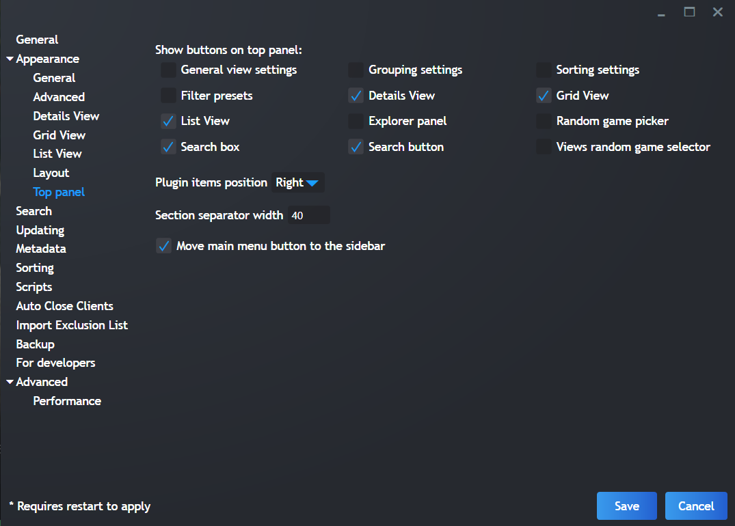

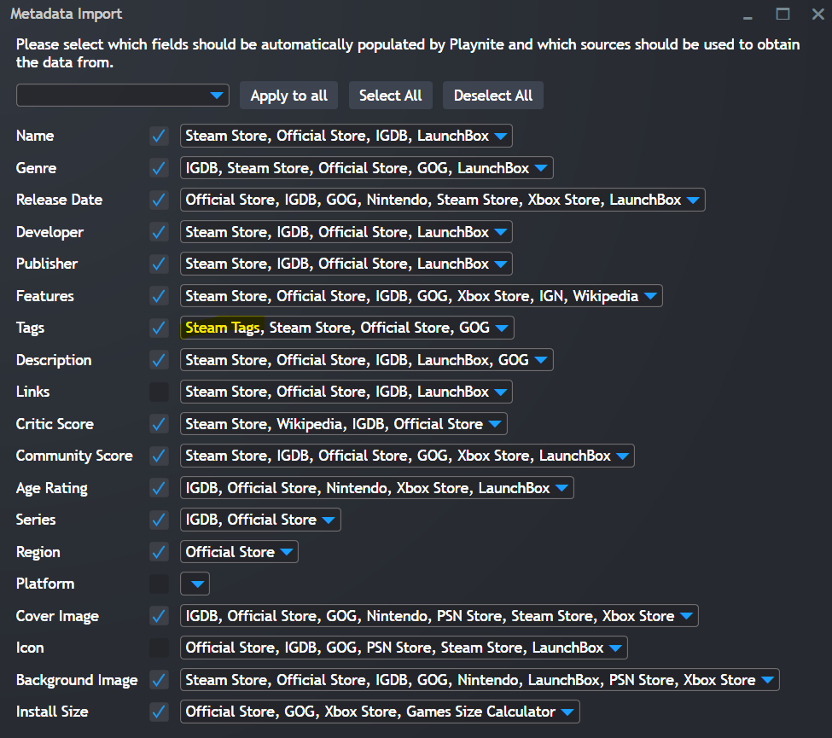 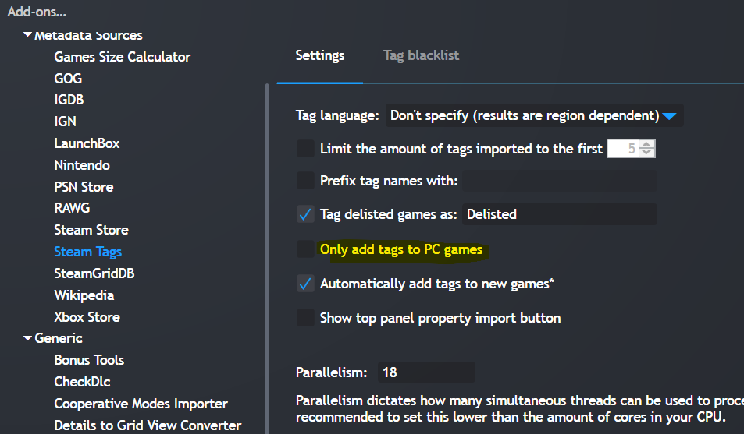

I recommend using these settings mainly to keep your metadata uniform.

If you select the Official Store instead as the first source, your data may become inconsistent, making it harder to filter by common tags/features, leading to a less enjoyable user experience.

Steam has usually the most comprehensive descriptions, tags and features.

By deselecting **Links**, you can use use the [LinkUtilities](https://playnite.link/addons.html#LinkUtilties_f692b4bb-238d-4080-ae76-4aaefde6f7a1) plugin instead, see also Cleanup links.

I use my “own” **icons** instead.

I prefer to use the icon of the Source/Platform rather than the icon of the game so I can quickly see the Platform associated with a game.

You can find the icons here: <https://github.com/tetj/BonusTools/tree/master/icons/source_icons>

I did not like having the background image:

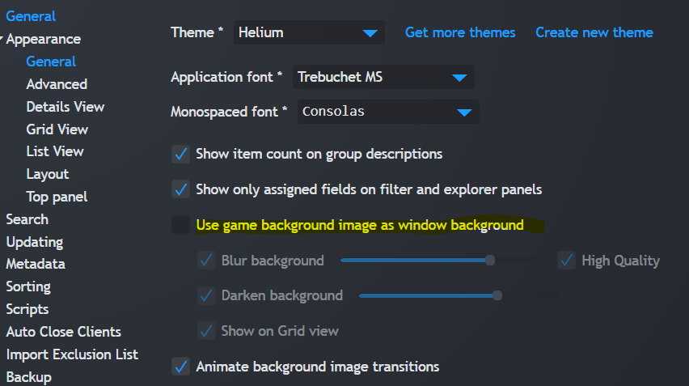

# ThemeModifier

To make text a brighter and easier to read: **TextBrush**: FFFFFFFF, **TextBrushDarker**: FFC0C0C0

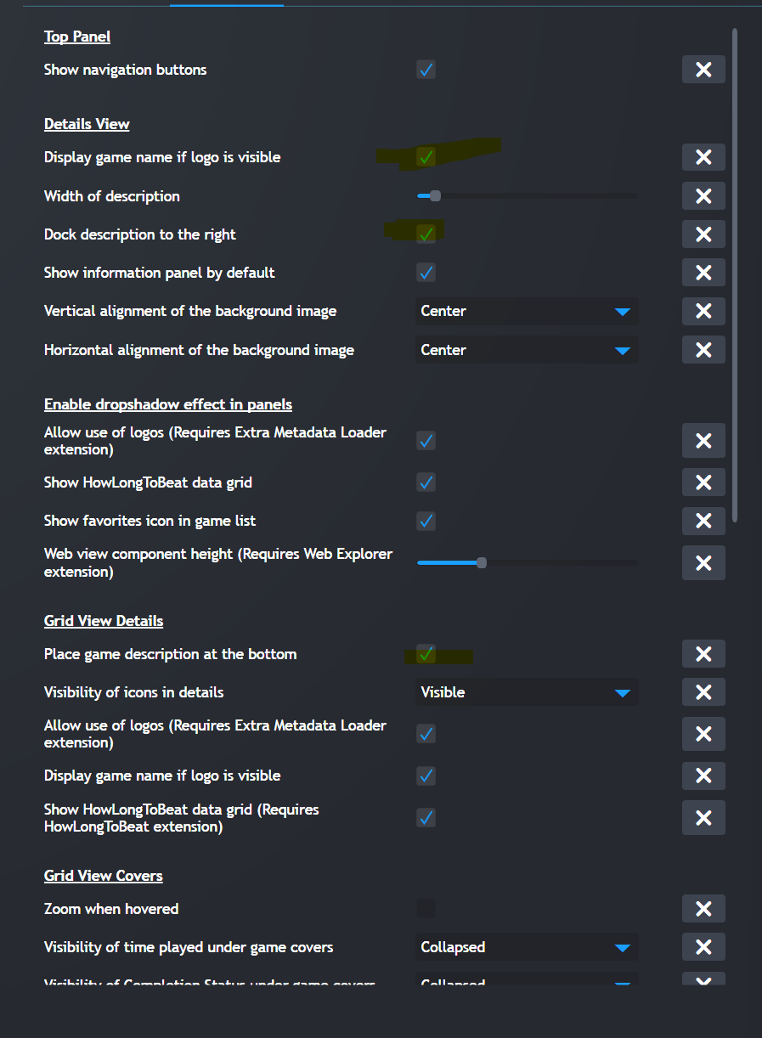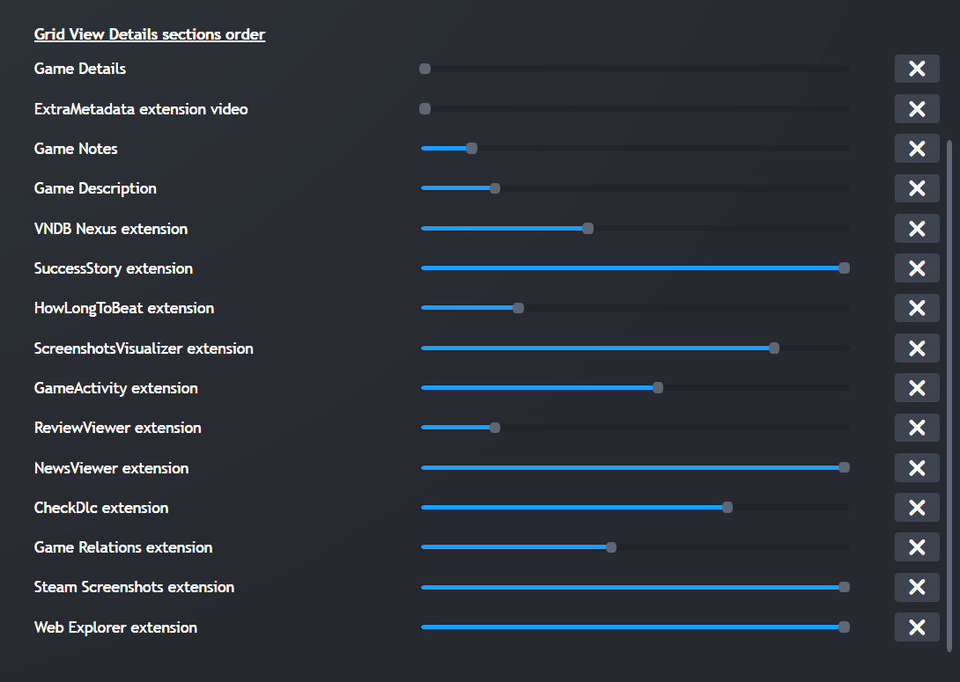

# Cleanup links

1. Remove all links by selecting all your games in the List View and editing them to remove the links
2. Select all your games - > Left click on a game -> [Link Utilities](https://playnite.link/addons.html#LinkUtilties_f692b4bb-238d-4080-ae76-4aaefde6f7a1) -> selected websites… -> OK (this will take forever if you have a large library)

GOG database could have been interesting but it did not work, same with Steam DB.

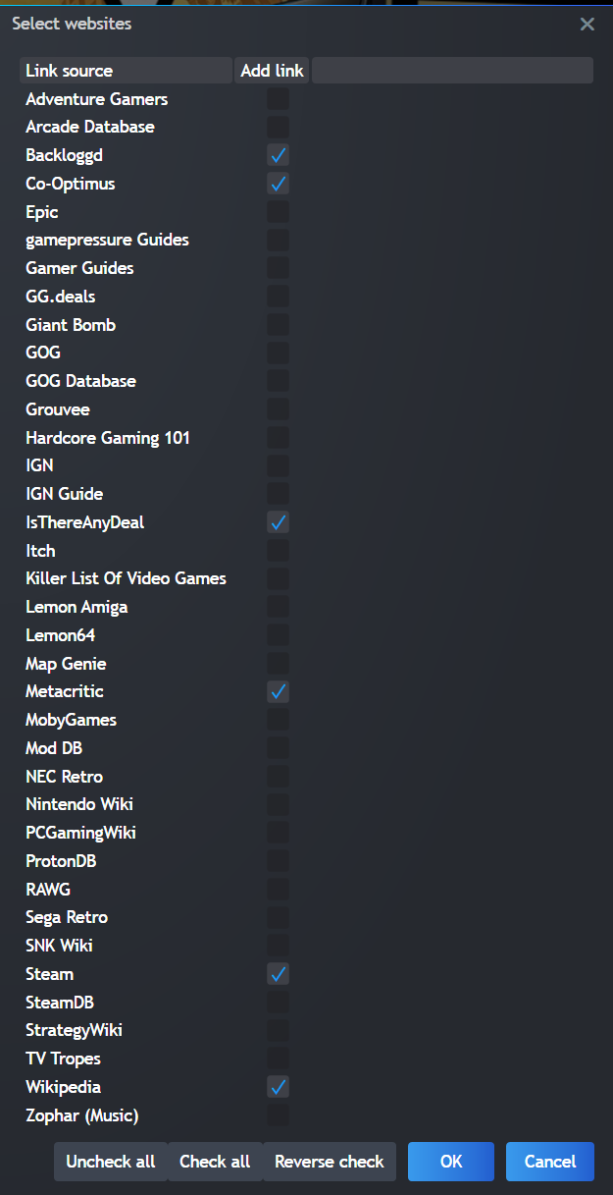

# Backups

I suggest frequent backups, especially if you have a huge library and are messing with it a lot.

Once a week is probably enough if you are not changing it daily.

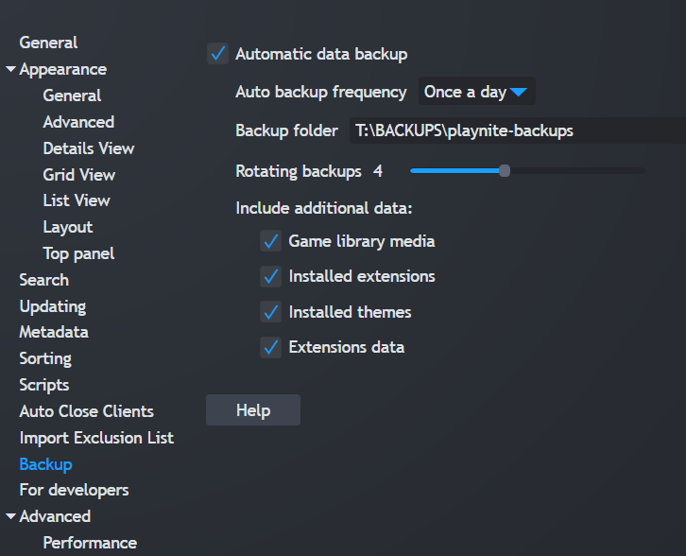

# General suggestions for improving Playnite

1. Work in progress …

# Suggestions for new extensions/themes

**A theme with features similar to Psprice.com:**

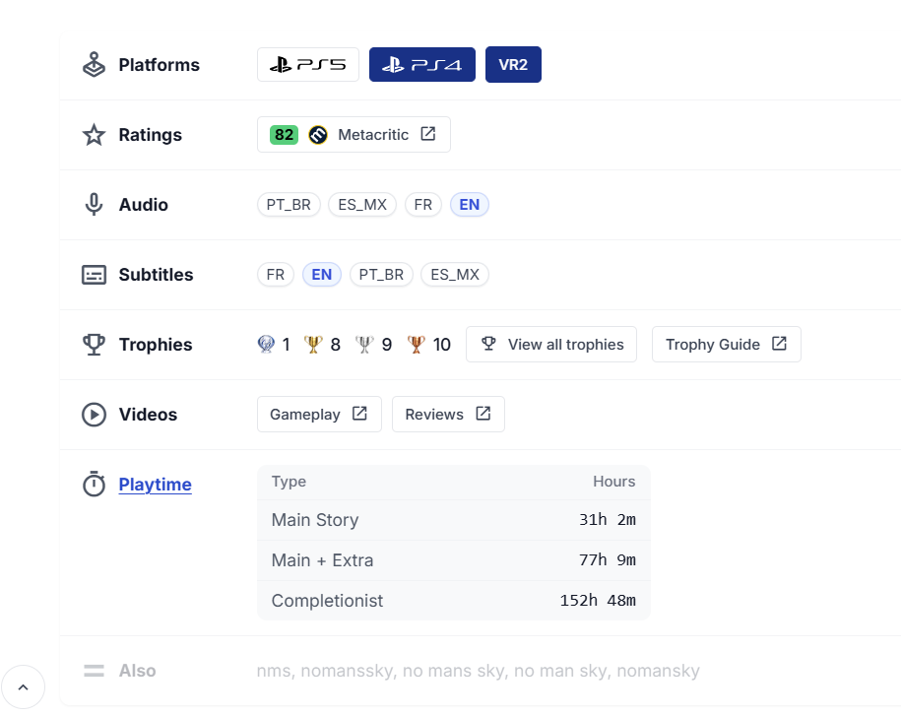

**From Psdeals.com:**

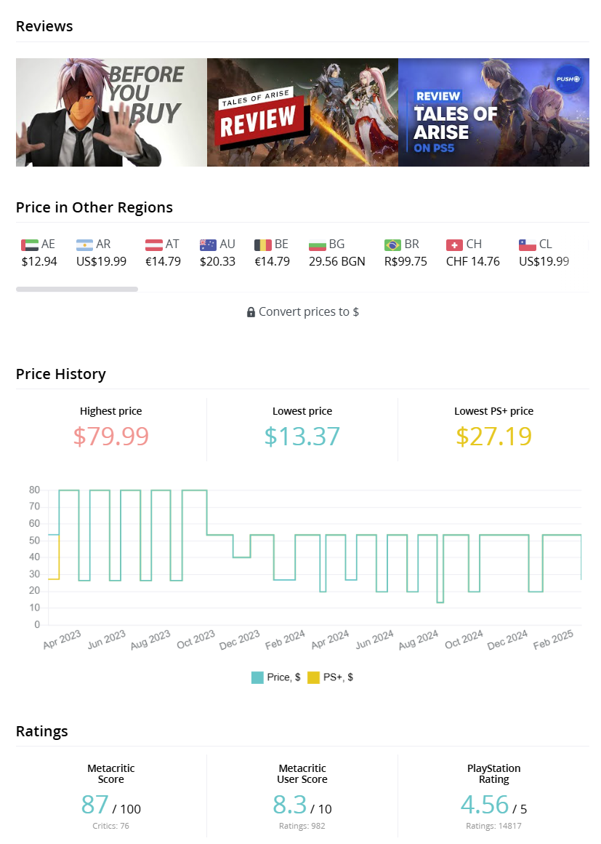

See : <https://github.com/mrt1m/playstation-store-api/blob/main/examples/get_product_star_rating.php>